https://www.instaclustr.com/deep-diving-into-cassandra-stress-part-1/

cassandra-stress is a great utility for stress testing Cassandra

1. what is about the most basic cassandra-stress command you can run:
cassandra-stress write n=10 -node x.x.x.x

- cassandra-stress: invokes a shell script which in turn invokes the main function of the Java class org.apache.cassandra.stress.Stress
- write: execute write operations (other options being read, mixed, user, counter_write and counter_read)
- n=10: execute 10 operations
- -node x.x.x.x: the address of a node in the cluster to establish the initial connection
Defaults:
Command:
Type: write
Count: 10
No Warmup: false
Consistency Level: LOCAL_ONE
Target Uncertainty: not applicable
Key Size (bytes): 10
Counter Increment Distibution: add=fixed(1)
Rate:
Auto: false
Thread Count: 200
OpsPer Sec: 0
Population:
Sequence: 1..10
Order: ARBITRARY
Wrap: true
Insert:
Revisits: Uniform: min=1,max=1000000
Visits: Fixed: key=1
Row Population Ratio: Ration: divisor=1.000000;delegate=Fixed: key=1
Batch Type: not batching
Columns:
Max Columns Per Key: 5
Column Names: [C0, C1, C2, C3, C4]
Comparator: AsciiType
Timestamp: null
Variable Column Count: false
Slice: false
Size Distribution: Fixed: key=34
Count Distribution: Fixed: key=5
Errors:
Ignore: false
Tries: 10
Log:
No Summary: false
Print Setting: true
File: null
Interval Millis: 1000
Level: NORMAL
Mode:
API: JAVA_DRIVER_NATIVE
Connection Style: CQL_PREPARED
CQL Version: CQL3
Protocol Version: V4
Username: null
Password: null
Auth Provide Class: null
Max Pending Per Connection: null
Connections Per Host: null
Compression: NONE
Node:
Nodes: [52.38.194.7]
Is White List: false
Datacenter: null
Schema:
Keyspace: keyspace1
Replication Strategy: org.apache.cassandra.locator.SimpleStrategy
Replication Strategy Pptions: {replication_factor=1}
Table Compression: null
Table Compaction Strategy: null
Table Compaction Strategy Options: {}
Transport:
factory=org.apache.cassandra.thrift.TFramedTransportFactory; truststore=null; truststore-password=null; keystore=null; keystore-password=null; ssl-protocol=TLS; ssl-alg=SunX509; store-type=JKS; ssl-ciphers=TLS_RSA_WITH_AES_128_CBC_SHA,TLS_RSA_WITH_AES_256_CBC_SHA;
Port:
Native Port: 9042
Thrift Port: 9160
JMX Port: 9042
Send To Daemon:
*not set*
Graph:
File: null
Revision: unknown
Title: null
Operation: WRITE
TokenRange:
Wrap: false
Split Factor: 1

Step by Step
As you can see, there is a lot going on behind the scenes. So. let’s walk-through step by step what cassandra-stress actually does when you execute this command:
  - The options provided through the command line are parsed and filled in with a whole range of default options as necessary (will touch on important defaults below and more in future articles). Interestingly, at this stage a valid cassandra.yaml will need to be loaded. However, as far as I could tell this is just a side effect of cassandra-stress using some core Cassandra classes and the contents of the cassandra.yaml have no effect on the actual cassandra-stress operations.
  - The Cassandra Java driver is used to connect to the node specified in the command line. From this node, the driver retrieves the node list and token map for the cluster and then initiates a connection to each node in the cluster.
  - A create keyspace (if one doesn’t already exist) command is executed with the following definition:
CREATE KEYSPACE IF NOT EXISTS keyspace1
WITH durable_writes = true
AND replication = {
'class' : 'SimpleStrategy',
'replication_factor' : 1
};

While this definition is a reasonable choice for a simple default, it’s important to note that this is unlikely to be representative of a keyspace you would want to run in production. By far the most common production scenario would be to use NetworkTopologyStrategy and a replication factor of 3. To have cassandra-stress create a keyspace with this strategy you would need to drop any existing keyspace and add the following parameters to the cassandra-stress command line:
-schema replication(strategy=NetworkTopologyStrategy,DC_NAME=3)
Replace DC_NAME with the actual name of your Cassandra data center. On some systems you may also need to escape the brackets ie. replication\(...\)

Once the keyspace is created, cassandra-stress creates two tables in the keyspace: standard1 and counter1. We’ll ignore counter1 for now as it’s not used in this test. The definition of the standard1 table created is as follows:
CREATE TABLE IF NOT EXISTS standard1
(key blob PRIMARY KEY,
"C0" blob, "C1" blob, "C2" blob, "C3" blob, "C4" blob) WITH COMPACT STORAGE AND compression = {};

While, again, this is a reasonable choice for a simple default, there are a few characteristics to keep in mind if you are trying to draw conclusions from performance using this table definition:
- There is no clustering key, so 1 row per partition – potentially very different performance to a scenario with many rows per partition.
- Compression is disabled – the overhead of compression is typically not huge but could be significant.
- Compact Storage is enabled – this is not enabled by default and will result in smaller representation of the data on disk (although minimal difference with Cassandra 3.x).
I’ll cover options for using different schemas in a later installment of this series.

cassandra-stress will attempt to make a jmx connection to the nodes in the cluster to collect garbage collection stats. If the attempt fails, the run will proceed without collection garbage collection stats.
- Next, cassandra-stress will run a warmup. This is a standard practice in load testing to reduce variation from start-up variation such as code being loaded to memory and JVM hotspot compilers. The number of warm-up iterations is the lesser 25% of the target of operations or 50k – 2 operations in this trivial example. The warm-up operations are basically the same as the test operations except not timed so I won’t go into them in detail.
- We’ve entered the actual load test phase. cassandra-stress creates 200 client threads and begins executing the target number of operations. In a real test, using the -rate option to control the number of client threads is a good way to control load on the cluster.
The first attempted operation will create a CQL prepared statement as follows:
UPDATE "standard1" SET "C0" = ?,"C1" = ?,"C2" = ?,"C3" = ?,"C4" = ? WHERE KEY=?
Although we were probably expecting an INSERT statement, updates and inserts are identical in terms of Cassandra implementation so we can expect performance to be the same.This prepared statement will then be will be executed 10 times with different, random data generated for each execution. The statement will be executed with consistent level LOCAL_ONE.cassandra-stress seeds the random generation with a static string plus the column name and a seed number which for the write command defaults to sequentially used numbers from 1 to the number of operations. That means that each column will get different values but the set of values generated will be the same over multiples runs. Generating a static set of values is necessary for read tests but does have the side effect that if you were to run our sample operation (write n=10) 1000 times the end result would still be just 10 rows of data in the table.
- Finally, cassandra-stress prints its results. Here’s an example from a run of this command:
- Results:
- Op rate : 545 op/s [WRITE: 545 op/s]
- Partition rate : 545 pk/s [WRITE: 545 pk/s]
- Row rate : 545 row/s [WRITE: 545 row/s]
- Latency mean : 35.9 ms [WRITE: 35.9 ms]
- Latency median : 37.2 ms [WRITE: 37.2 ms]
- Latency 95th percentile : 42.8 ms [WRITE: 42.8 ms]
- Latency 99th percentile : 42.8 ms [WRITE: 42.8 ms]
- Latency 99.9th percentile : 42.8 ms [WRITE: 42.8 ms]
- Latency max : 42.8 ms [WRITE: 42.8 ms]
- Total partitions : 10 [WRITE: 10]
- Total errors : 0 [WRITE: 0]
- Total GC count : 0
- Total GC memory : 0.000 KiB
- Total GC time : 0.0 seconds
- Avg GC time : NaN ms
- StdDev GC time : 0.0 ms
- Total operation time : 00:00:00
- Many of these results are self explanatory but some bear further explanation:
Op rate is the rate of execution commands. Partition rate is that rate that partitions were visited (updated or read) by those commands and Row rate is that rate that rows were visited. For simple, single-row commands all three rates will be equal. The rates will vary in more complex scenarios where a single operation might visit multiple partitions and rows.
Similarly, Total partitions is the total number of partitions visited during the test. It’s worth noting that this is not unique partitions so even in some write-only scenarios it may not reflect the total number of partitions created by the test.
The GC statistics report on garbage collection and are zero in this case as JMX ports were blocked to the test cluster.
Firstly, let’s look at the most simple invocation of the mixed command:
cassandra-stress mixed n=100 -node x.x.x.x
First thing to note about this command is that for it to work you need to have run a write command to create the schema and populate data before the run. The write command should be run with at least the same number of operations as the mixed command to ensure that read commands will all retrieve data. For example, to prepare for the above command you should run:
cassandra-stress write n=100 -node x.x.x.x
If you haven’t written the right data before you run the mixed test then you will receive errors like the following:
java.io.IOException: Operation x0 on key(s) [38374d394b504d353430]: Data returned was not validated
This is because cassandra-stress validates the data returned from the select operations against the generated data set expected for the row (and in this case no data was returned).
So, once you’re set up correctly, what will the command actually do? The key default settings that come into play are:
- Consistency level: LOCAL_ONE – particularly significant for reads as it means only a single node will need to perform each read (vs multiple nodes for the more common QUORUM consistency levels)
- Command Ratios: {READ=1.0, WRITE=1.0} – the operations will be split evenly between reads and writes
- Command Clustering Distribution: clustering=GAUSSIAN(1..10) – determines the number of consecutive read or write operations to conduct consecutively. So, in this case will perform between 1 to 10 reads before performing between 1 to 10 writes and then switching back to reads. Due to this clustering, the actual ratio of reads to writes may differ from the target specified in command ratios for small runs such as this. However, it should even out over the course of a longer run.
- Population Distribution: Gaussian: min=1,max=100,mean=50.500000,stdev=16.500000 – unlike the write command, which uses a sequence from 1 to number of ops, mixed uses randomly generated numbers from 1 to the number of ops as part of the seed for the actual values. As the range is the same as write operations, the values are guaranteed to overlap between write and mixed but the the mixed run will potentially not visit all possible values and will visit them in a random order (of seed values).
- Rate: Auto, min threads = 4, max threads = 1000 – cassandra-stress will perform multiple runs, start at 4 threads and increasing threads with each run until the total operation rate fails to increase for three consecutive runs. The number of threads used will double with each run up to 16 threads and then increase by 1.5 times with each run after that.
The rate setting illustrates an interesting point in using cassandra-stress: generally, increasing the number of client threads will increase the load (throughput) you are placing on the cluster. This is because all operations are executed synchronously (in order to time them) and so more threads allow more operations to be simultaneously thrown at the cluster. Of course, like any multi-threaded system, there is an overhead incurred managing threads on the stress client and a limit to how much work the client can do before it becomes a bottleneck to the test. So, increase threads to increase the load on your cluster but check when you hit the limit that it’s actually your cluster reaching its limit not your stress client.
That’s it for the mixed command and associated info. Future installments will look at some of the other key options and the yaml configuration file.
- In this post I will start looking at the use of the stress YAML file for more advanced stress scenarios, particularly where you want to run stress against a schema that matches one you are planning to use for your application.

#
# Keyspace name and create CQL
#
keyspace: stressexample
keyspace_definition: |
CREATE KEYSPACE stressexample WITH replication = {'class': 'NetworkTopologyStrategy', 'AWS_VPC_US_WEST_2': '2'};
#
# Table name and create CQL
#
table: eventsrawtest
table_definition: |
CREATE TABLE eventsrawtest (
host text,
bucket_time text,
service text,
time timestamp,
metric double,
state text,
PRIMARY KEY ((host, bucket_time, service), time)
) WITH CLUSTERING ORDER BY (time DESC)

#
# Meta information for generating data
#
columnspec:
- name: host
size: fixed(32) #In chars, no. of chars of UUID
population: uniform(1..600) # We have about 600 hosts with equal events per host
- name: bucket_time
size: fixed(18)
population: uniform(1..288) # 288 potential buckets
- name: service
size: uniform(10..100)
population: uniform(1000..2000) # 1000 - 2000 metrics per host
- name: time
cluster: fixed(15)
- name: state
size: fixed(4)

#
# Specs for insert queries
#
insert:
partitions: fixed(1) # 1 partition per batch
batchtype: UNLOGGED # use unlogged batches
select: fixed(10)/10 # no chance of skipping a row when generating inserts

#
# Read queries to run against the schema
#
queries:
pull-for-rollup:
cql: select * from eventsrawtest where host = ? and service = ? and bucket_time = ?
fields: samerow # pick selection values from same row in partition
get-a-value:
cql: select * from eventsrawtest where host = ? and service = ? and bucket_time = ? and time = ?
fields: samerow # pick selection values from same row in partition
Before explaining the contents here, let’s see what happens when we run it with the following simple scenario:
cassandra-stress user profile=file:///eg-files/stressprofilemixed.yaml no-warmup ops(insert=1) n=100 -rate threads=1 -node x.x.x.x
After running this on an empty cluster, I ran select count(*) from eventsrawtest;. The result? 345 rows – probably not you would have guessed. Here’s how cassandra-stress gets to that:
n=100 counts number of insert batches, not number of individual insert operations
- Each batch will contain 1 partition’s data (due to partitions=fixed(1) setting) and all 15 of the rows in the partition. There are 15 rows in every partition as the single cluster key (time) has a cluster setting of fixed(15). All the rows in the partition will be included in the batch due to the select: fixed(10)/10 setting (ie changing this to say fixed(5)/10 would result in half the rows from the partition being include in any given batch).
- 100 batches of 15 rows each gets you to 1500 rows so how did we end up with 345? This is due (primarily, in this case) to the relatively small range of potential values for the bucket_time. This results in a high overlap in the partition key values that end up getting generated by the uniform distributions. To demonstrate, changing the population of bucket_time to uniform(1..1288) results in 540 rows. In most cases, you want to initially insert data with no overlap to build up a base data set for testing. To facilitate this, I’ve recently submitted a cassandra-stress enhancement that provides sequential generation of seed values the same as used with the write command (https://issues.apache.org/jira/browse/CASSANDRA-12490). Changing the uniform() distribution to seq() results in the expected 1500 rows being inserted by this command.
Let’s look at some of the other column settings:
- population – determines the distribution of seed values used in the random data generation. By controlling the distribution of the seed values you control the distribution of the actual inserted values. So, for example uniform(1..100) will allow for up 100 different values each with the same chance of being selected. guassian(1..100) will also allow for up to 100 different values but as they will follow a guassian (otherwise known as normal or bell-curve) distribution, the values around the middle will have a much higher chance of being selected than the values at the extremes (so there will be a set of values more likely to get repeated and some which will occur very infrequently).
- size – determines the size (length in bytes) of the of the values created for the field.
- cluster – only applies to clustering columns, specifies the number of values for the column appearing in a single partition. The maximum number of rows in a partition is therefore the product of the maximum number of row of each clustering column (eg max(row1) * max(row 2) * max(row3)).

We covered most of the insert settings in the introductory points but here’s a recap:
- partitions: the number of different partitions to include in each generated insert batch. Once a partition is chosen for inclusion in a batch, all rows in the partition will become eligible for inclusion and then be filtered according to the select setting. Using, uniform(1..5) would result in each batches containing between 1 and 5 partitions worth of data (with an equal chance of each number in the range).
- batchtype: logged or unlogged – determines the cassandra batch type to use
- select: select determines the portion of rows from a partition to select (at random) for inclusion in particular batch. So, for example, fixed(5)/10 would include 50% of rows from the selected partition in each batch. uniform(1..10)/10 would result in between 10% and 100% of rows in the partition being included in the batch with a different select percentage being randomly picked for each partition in each batch.

The final section the yaml file that bears some explanation is the queries section. For each query, you specify:
- A name for the query (pull-for-rollup, get-a-value) which are used to refers to the queries when specifying the mix of operations through the cassandra-stress command line.
- cql – The actual query with ? characters where values from the population will be substituted in.
- fields – either samerow or multirow. For samerow, the key values to use for the select will be picked at random (following the same general population rules as for insert) for the list of row keys that has been generated for inserting. For multirow, each of the column values making up the key will be independently randomly selected so there is a chance of generating keys for the selection parameters that don’t exist in the set of data that will/could be inserted according the the population settings.

The ops command specified as part of the command line controls the mix of different operations to run. Take for example the following command:
cassandra-stress user profile=file:///eg-files/stressprofilemixed.yaml ops(insert=1, pull_for_rollup=1, get-value=10) n=120 -node x.x.x.x
This will execute insert batches, pull_for_rollup queries and get-value queries in the ratio 1:1:10. So for this specific example, we’d get 10 inserts, 10 pull_for_rollup queries and 100 get-value queries.
Hopefully that’s explained the key information you need to use a YAML profile for running cassandra stress. In future instalments I’ll take a look at some of the remaining command line options and walk through a full end-to-end example of designing and executing a test.

Test Run
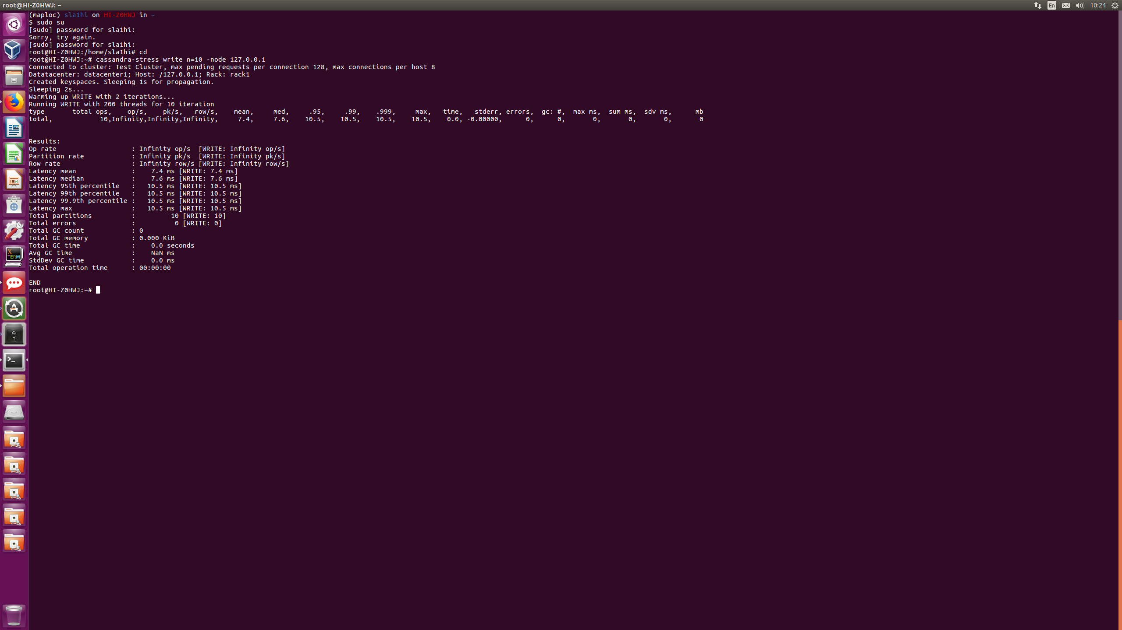
Looking further..
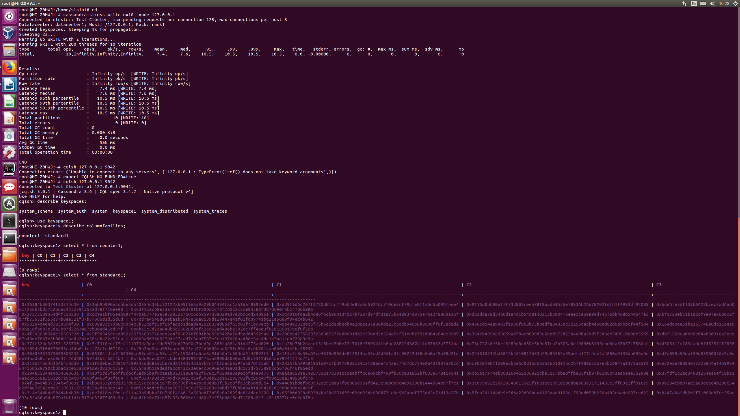

Write test
